MEMORANDUM

This Memorandum of Understanding (the “Agreement”) is entered into as of the ____ day of June, 2020, by and between:

BELLE REALTY OF LAFAYETTE, L.L.C., a Louisiana limited liability company, whose current mailing address is 101 Arnould Boulevard, Lafayette, Louisiana 70506 (hereinafter referred to as the “Lessor”);

and

THE PINK PAISLEY, LLC, a Louisiana limited liability company, whose mailing address during the term of this Lease shall be 1216 N Dugas Road, Lafayette, Louisiana 70507, (hereinafter referred to as the “Lessee”).

WITNESSETH:

WHEREAS, Lessor is the owner of that certain real property together with improvements located thereon known as The Boulevard Shopping Center located in Lafayette, Lafayette Parish, Louisiana (“Boulevard Shopping Center Property”).

WHEREAS, Lessee wishes to lease two certain portions of the Boulevard Shopping Center Property from Lessor according to the terms and conditions set out herein.

NOW, THEREFORE, in consideration of the foregoing and other good and valuable consideration herein, the sufficiency of which is hereby acknowledged, the parties hereto agree as follows:

Section 1.01 – Premises:

A.

IN WITNESS WHEREOF the parties hereto have executed this Agreement the day and year first above.

WITNESSES: LESSOR:

BELLE REALTY OF LAFAYETTE,
Printed Name: L.L.C., a Louisiana limited liability
company

By:
Printed Name: Adam A. Abdalla
Authorized Representative

_________________________________
Notary Public

IN WITNESS WHEREOF the parties hereto have executed this Agreement the day and year first above.

WITNESSES: LESSEE:

THE PINK PAISLEY, LLC,
Printed Name: a Louisiana limited liability company

By:
Printed Name: Amy M. Lemoine
Member/Manager

_________________________________
Notary Public

SCHEDULE A

BOULEVARD SHOPPING CENTER PROPERTY PLAT

SHOWING PREMISES LEASED

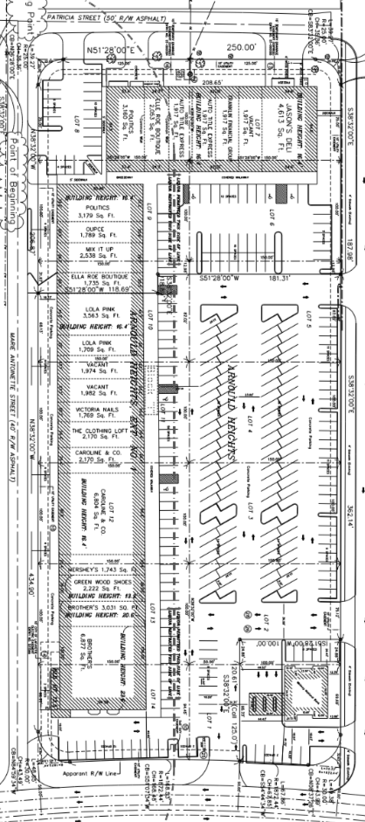
SCHEDULE B

BOULEVARD SHOPPING CENTER PROPERTY

SITE PLAN SHOWING COMMON AREA

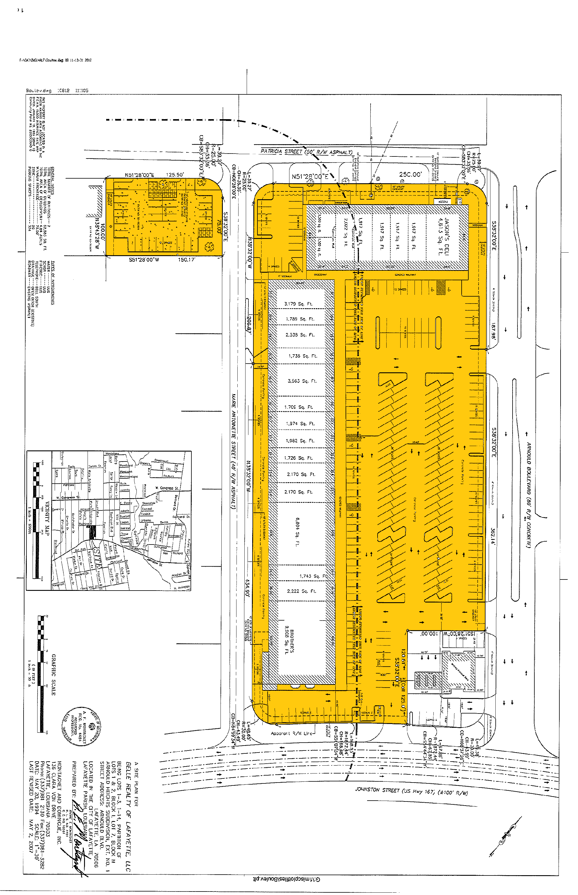

SCHEDULE C

THE BOULEVARD SHOPPING CENTER PROPERTY

RULES AND REGULATIONS

All loading and unloading of goods shall be done only at such times, in the areas, and through the entrances, designated for such purposes by Lessor.

The delivery or shipping of merchandise, supplies, and fixtures to and from the Premises shall be subject to such rules and regulations, which in the sole judgment of Lessor are necessary for the proper operation of the Premises or the Boulevard Shopping Center (the “Shopping Center”).

All garbage and refuse shall be kept in the kind of container or receptacle specified by Lessor, and shall be placed in the area outside of the Premises prepared for collection in the manner and at the times and places specified by Lessor.

No radio or television or other similar device shall be installed without first obtaining, in each instance, Lessor’s prior consent in writing. No aerial or antenna of any kind shall be erected on the roof or exterior walls of the Premises, the building in which the Premises is located or on the grounds of the Shopping Center, without, in each instance, the prior written consent of the Lessor. Any aerial or antenna so installed without such written consent shall be subject to removal by the Lessor without notice at any time.

No loud speakers, televisions, phonographs, radios, or other devices shall be used in a manner so as to be heard or seen outside of the Premises without the prior written consent of Lessor.

If the Premises are equipped with heating facilities separate from those in the remainder of the Shopping Center, Lessee, during winter months shall keep the Premises heated at a temperature sufficient to prevent freezing of water in pipes and fixtures located within the Premises.

The exterior areas immediately adjoining the Premises shall be kept clean and free from snow, ice, dirt, trash, refuse and rubbish by Lessee to the satisfaction of Lessor, and Lessee shall not place or permit any obstruction or merchandise in such areas.

The plumbing facilities within the Premises shall not be used for any other purpose than that for which they are designed, and no foreign substance of any kind shall be thrown therein, and the expense of any breakage, stoppage, or damage resulting from a violation of this provision shall be borne by Lessee.

Lessee shall use, at Lessee’s cost, a qualified pest extermination contractor, whose services shall be scheduled so as not to reasonably interfere with the operation of the Shopping Center.

Lessee shall not burn any trash or garbage of any kind in or about the Premises, the Shopping Center, or within one mile of the outside property lines of the Shopping Center.

Lessee and Lessee’s employees shall park their cars only in those parking areas designated for that purpose by Lessor.

Lessee shall not make noises, cause disturbances, or create odors, which may be offensive to other tenants of the Shopping Center or their officers, employees, agents, servants, customers or invitees.

Lessee shall not place any type or kind of electrical power extension cord or light fixture outside of the Premises. The Lessee shall use only UL approved, ground faulted power strips to facilitate electrical power sources within the Premises.

Lessee shall not, without the prior written consent of the Lessor, hang or cause to be hung, any banner, sign, display or any other items of any kind outside of the Premises (including the lattice which is part of the building in which the Premises is located).

Lessee shall not, without the prior written consent of the Lessor, stand, erect, construct or otherwise place any display or any other thing of any kind whatsoever in front of the Premises.

Lessee’s business operation located within the Premises shall be open for business a minimum of five (5) days per each calendar week, Monday through and including Friday. In addition, such business operation shall be open during those days at least from 10:00 a.m. each day to 5:00 p.m. each day. Nothing contained herein shall prevent the Lessee from opening for business on Saturday or Sunday of each calendar week. In the event the Lessee’s business operations do not, for any reason, remain open for retail business as set forth herein, the Lessee shall be subject to a fine by the Lessor in any amount not to exceed $100.00 for each occurrence. Further provided, in the event of five (5) or more such occurrences within any twelve (12) month period, the Lessor shall have the right, in addition to all other remedies contained herein to terminate this Agreement. Notwithstanding anything contained herein to the contrary, the Lessee shall not be obligated to be open for business on the following holidays: New Years Day, Mardi Gras Day, Easter Sunday, Thanksgiving Day and Christmas Day.

In the event the Lessee displays any clock or other time keeping device on the Premises which is visible from the exterior, the same shall be maintained in a manner to display the accurate time at all times, including the adjustment of such time to reflect daylight savings time and standard time and to compensate for any power outages which may have affected such clock or time keeping device.

In the event the Lessee displays or otherwise employs a sign which is lighted by electrical current or otherwise, then the Lessee shall ensure that such signs are lighted as of dusk each day (adjusted for seasonal changes in such time) and remain lighted until midnight each day.

Lessee shall cause its name and address to be placed on the rear door of the Premises and shall, at its own expense, provide for security lighting to be placed on or about the rear door, which security lighting shall remain illuminated all night, every night.

Lessee shall not, nor shall Lessee permit any of its employees, contractors, customers or invitees to, solicit business or otherwise from any person or persons located on the Shopping Center property. Further, Lessee shall not respond or otherwise encourage or facilitate the solicitation by any outside person or persons on the Shopping Center property.

SCHEDULE D

DESIGN CRITERIA FOR LESSEE SIGNS

AT THE BOULEVARD SHOPPING CENTER

Lessee’s sign or signs shall be store identity signs only, and must be placed on the exterior façade of the canopy which covers the sidewalk in front of the Premises (the “Canopy”) in the area designated for signs. No signs shall be suspended from the underside of the façade, but may, subject to the approval of the Lessor, be suspended from the underside of the Canopy.

No freestanding signs shall be permitted.

Lessee’s signage shall be manufactured by Universal Sign Company and be Individual Channel Illuminated letters, interior light with single 12mm white neon, five and one-half (5 ½”) inch deep Channel letters using .040 aluminum with bronze factory baked enamel finish, plastic facing, using 1” Jewelite gold Trim cap.

Letter style may be of the Lessee’s choice, subject to review and written approval by Lessor prior to the sign order being placed with the company.

Lessee’s sign shall be limited to letters not to exceed twenty-six (26”) inches in height. The maximum length of Lessee’s lettering may be 80% of the frontage of the Premises, but no letters shall be nearer than two (2’) feet to either corner of the Premises. No exposed neon light shall be used on signs without Lessor’s prior written approval.

All neon on interior of letters to be UL48 specifications, PK housing, electrical conduit, etc. Letters to be mounted on a raceway, shall not exceed store identity name with cabinet being a maximum eight (8”) inches width and eight (8”) inches depth (transformers mounted in raceway); the raceway shall be painted the same color of the building fascia to which it will be attached.

Lessee’s lettering on doors, windows or show windows may not be illuminated and may not exceed six (6”) inches in height.

Lessee’s shall not employ paper signs to be applied to the interior or exterior faces of the store front glass or other material. Lessee shall not employ any flashing action, moving action or audible signs.

Lessee’s sign shall be in accordance with ordinances of governing bodies having jurisdiction over the Shopping Center, the Premises and/or the Lessee.

Lessee’s signs shall operate in a manner which automatically turns the sign(s) on at dusk and turns the sign(s) off at 12:00 midnight each day.

Lessor’s approval of Lessee’s plans and specifications for space improvement work shall not be deemed to constitute approval by Lessor of any of Lessee’s sign work. Lessee shall submit separate drawings and specifications, in quadruplicate, including colors, for all its proposed sign work. The drawings shall clearly show the location of all signs on the storefront elevation drawing, graphic, color and construction and attachment details. Within a reasonable time after the receipt of such drawings and specifications, Lessor shall return one set thereof to Lessee with its approval and/or any suggested modifications from Lessor. Lessee shall be deemed to have agreed to and approved all suggested modifications.

All Lessee signs must be fully approved in writing by Lessor prior to installation.

In the event that Lessee places or otherwise erects a sign or signs in any place other than within the Premises without the prior written approval of the Lessor, the Lessor shall have the right to remove such sign or signs and the costs or removal shall be the responsibility of the Lessee. The Lessee shall reimburse the Lessor for such costs within five (5) days of receipt of an invoice from the Lessor for the costs of removal of the sign or signs. The cost of such removal shall be considered rent due hereunder and the non-payment by the Lessee shall be considered non-payment of rent and entitle the Lessor the exercise its rights for non-payment of rent.

